Objective Questions:
- What is the total number of attributes in the customer table?
Answer: 3 attributes
Approach: Attributes means columns of a specified table

- How will you get the “Customer’s” ages in the “Order” tables according to customer IDs?
Answer: Added in the PBI file
Approach: Add calculated column in Orders tab and then used “Related” function to fetch the age from Customer sheet using Customer ID

- In analyzing the dataset with Power BI, ensure data cleaning to address inconsistencies and missing values before further analysis.
Answer: Removed Null from Location, ProductCategory & Unit Price column in Orders table
Removed Null : Filtered out NULL from each column of Orders table
Changed Type : Changed the format of OrderDate column to Date datatype.

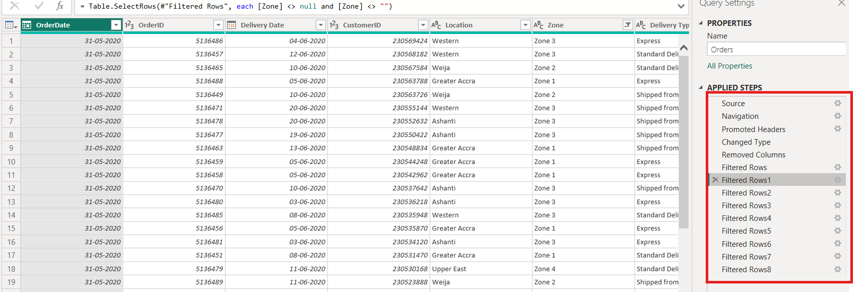

- How can we calculate the total revenue generated by all the sales?
Answer: 107.24M
Approach: Used sum DAX to calculate the total revenue i.e Unit Price * Order Quantity
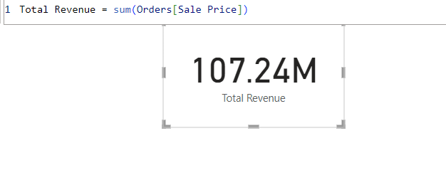
- What is the total number of unique customers who made purchases each year? Is there any increase in the number over the years?
Answer: Total number of unique customers each year is 113K
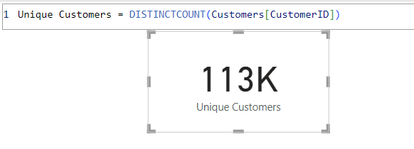
Approach: Used DistinctCount to find the unique customer ID in Orders table.
Observation: Year wise customer graph shows an increase only for the year 2020, before which there has not been any growth, can be mostly considered as stagnant.

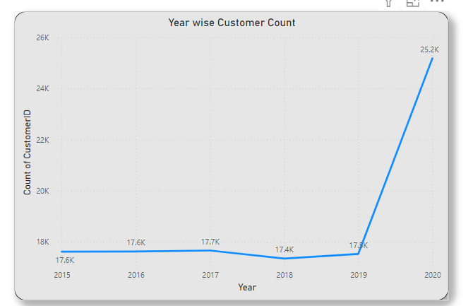

- How can we determine the total number of unique products available in the company?
Answer: 44
Approach: Used “Distinct Count” to find the unique product count
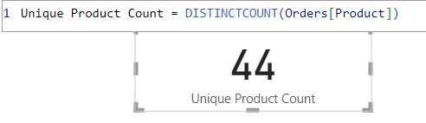

- What is the average number of days it takes for products to be delivered, get the metric for only the delivered orders.
Answer: 9.41 days
Approach : Used AverageX, Filter & datediff formula to calculate the avg delivery days for the orders which has been delivered.
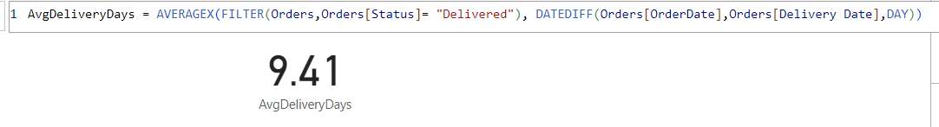

- Which products, categories, and subcategories are the most popular?
Answer: Below are the most popular items:
Product :- Canon EOS 600D 18MP CMOS DSLR Camera - Black
Categories :- Phones and Tablet
Subcategories :- Digital Cameras
Approach: Used Column Chat to create the Visualization for most popular criterias:

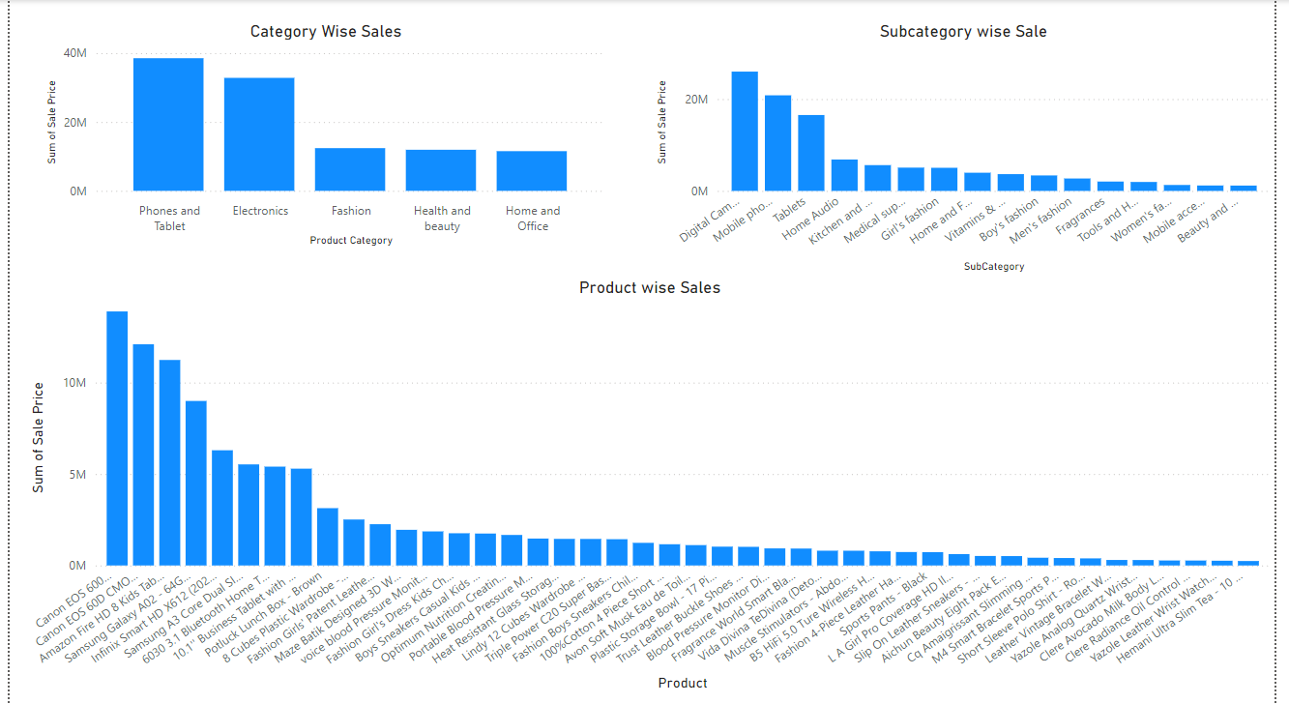

- Which products have seen an increase or decrease in sales over the year?
Answer: All Products have seen an increase in sales from 2015 to 2020 but almost all products have seen the decrease in sale in between these periods. I have created a view with YoY% with a product slicer to understand this better.
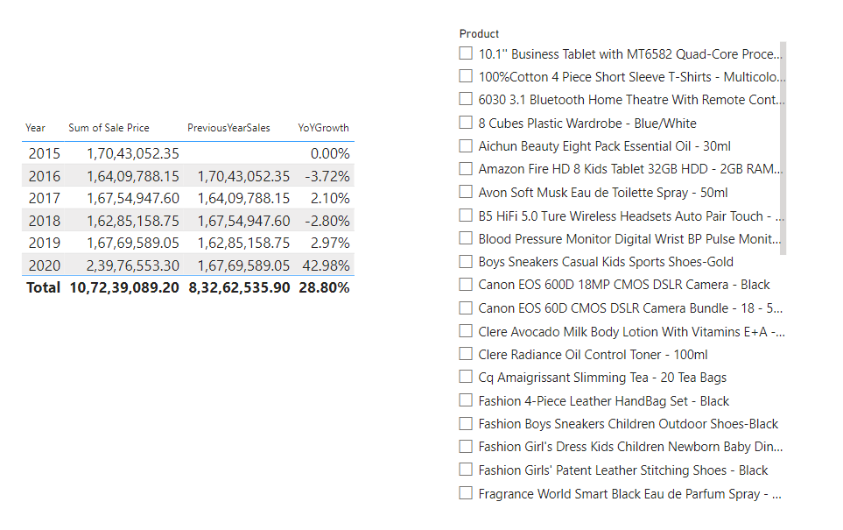

- While modeling the data relationships, what will be the type of relationship between the customer ID of Orders and customer tables?
Answer: Many to one relationship between Orders and Customer table

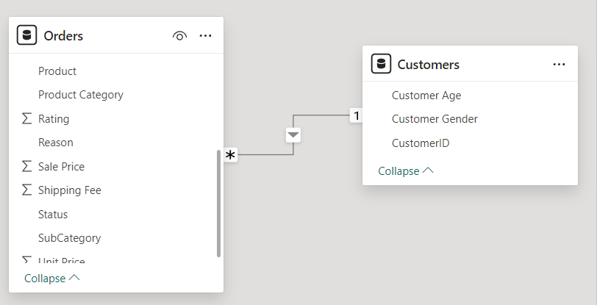
- How have you handled the null values in the data?
Answers: I have excluded the null values from the data set and the count was too minimal.

- Were there any data format issues in the data, and if there were/are how you would handle them?
Answer: There was data format issue with the Order Date & Delivery date which I corrected by using Date Format on both these cells
For Order Date and Delivery date the datatype was incorrect - hence used the below feature in PBI to change the format type of these columns to DATE
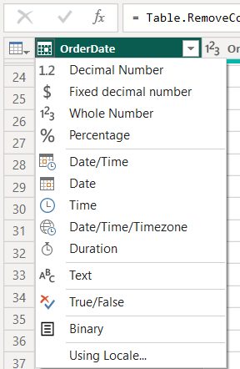

- When we add a column in Power Query what’s the code that comes in M language in the formula bar? What do you know about M-query?
Answer: If we add a customer column then the formula bar shows something like:
—> Table.AddColumn(PreviousStep, "New Column Name", each <Expression>)
An M-query in Power BI refers to the code written in M language (or Power Query Formula Language), used within the Power Query Editor. M is a case-sensitive, functional language designed for data manipulation tasks such as importing, cleaning, and transforming data.

Key Concepts of M-Query:
- Data Source Connection: M-queries define how Power BI connects to and pulls data from various sources like Excel, SQL Server, APIs, etc.
- Transformations: M-queries specify data transformation steps, such as filtering, grouping, pivoting/unpivoting columns, or changing data types.
- Applied Steps: Each step in the Power Query Editor corresponds to a line of M-code, which represents a specific operation performed on the data.
- Code Syntax: M-code is written in a structured format with a sequence of transformation steps connected logically.

M-Query in Power Query Editor
- Open the Power Query Editor.
- Perform transformations using the UI; this automatically generates M-code.
- Click Advanced Editor to view or modify the M-query directly.

Benefits of M-Queries
- Customizable: You can manually write or tweak the query for specific requirements.
- Reusable: Copy and adapt M-code for similar data transformations.
- Powerful: Enables complex data transformation and integration tasks.

- Identify the top 5 most valuable customers using a composite score that combines three key metrics: (SQL)
  - Total Revenue (50% weight): The total amount of money spent by the customer.
  - Order Frequency (30% weight): The number of orders placed by the customer, indicating their loyalty and engagement.
  - Average Order Value (20% weight): The average value of each order placed by the customer, reflecting the typical transaction size
Answer: There are multiple CustomerID with similar Composite Score 5726 - hence used Rank function to pull all the top Composite Score CustomerID
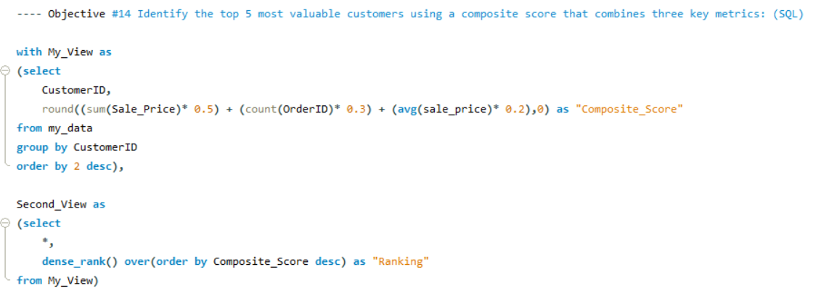
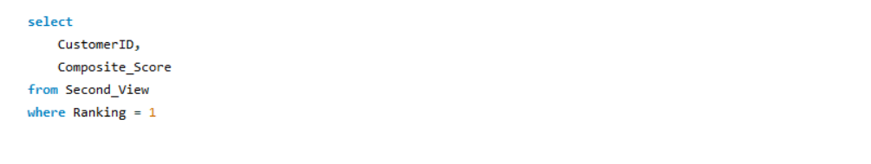
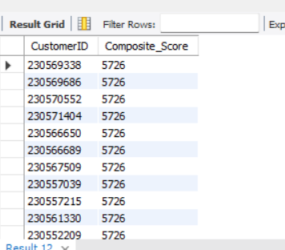

- Calculate the month-over-month growth rate in total revenue across the entire dataset. (SQL)
Answer: First Created Monthly revenue then created Previous Month revenue using LAG function in SQL, below is the visualized view of the same.

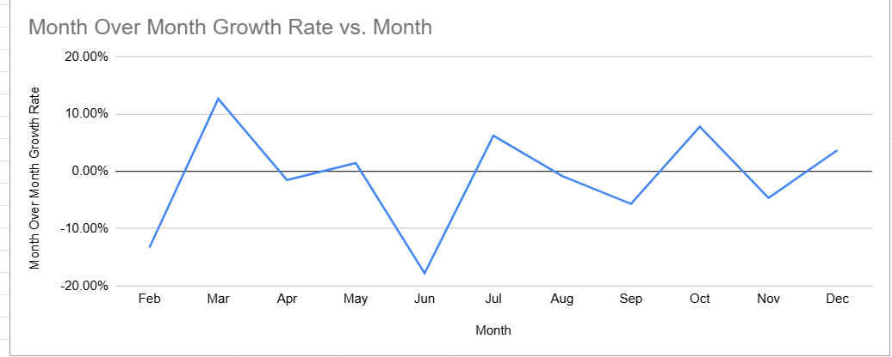

Query:
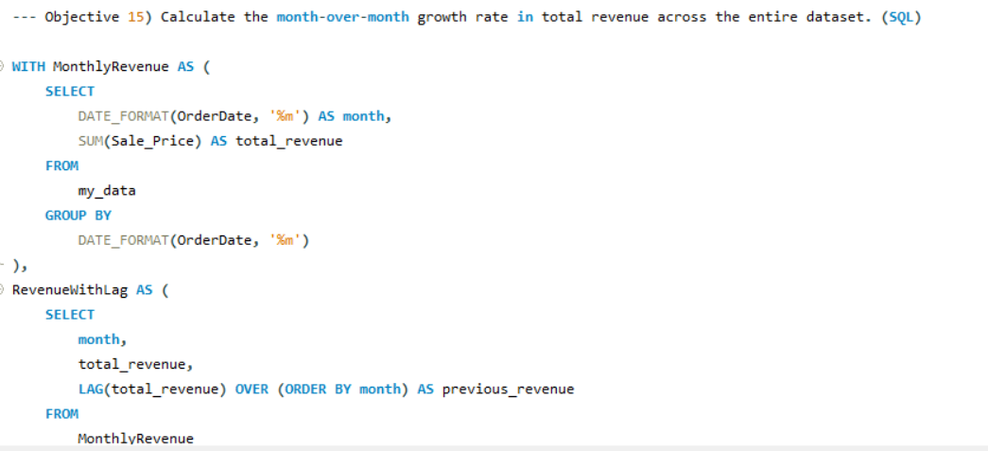
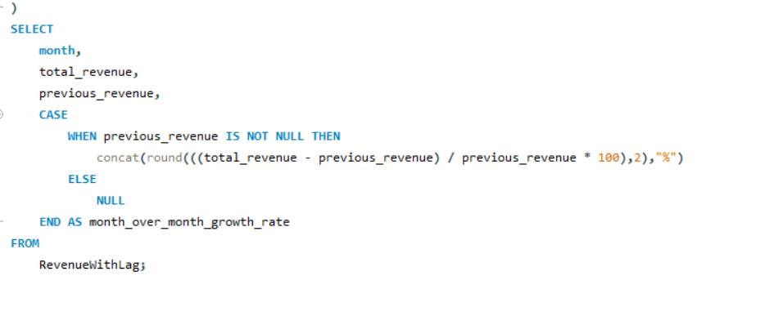

Output:
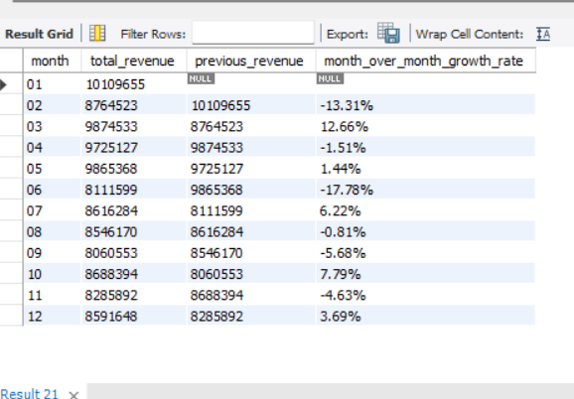

- Calculate the rolling 3-month average revenue for each product category. (SQL)
Answer: Below Snap shows the 3 month average revenue year wise for each product category, view available in PBI report - page name “Objective 16”
Approach: First created Month Year column in Orders table and then created a new Measure : 3 month_avg_revenue with formula :
CALCULATE(AVERAGE(Orders[Sale Price]), DATESINPERIOD(Orders[Month Year],LASTDATE(Orders[Month Year]),-3,MONTH))
Finally used Table view to display the outcome.

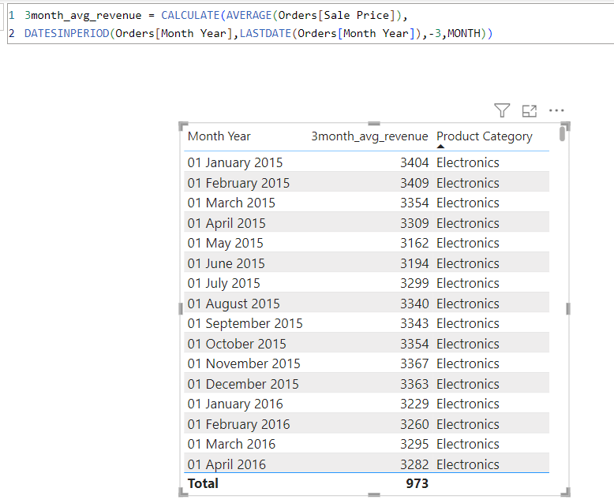

- Update the orders table to apply a 15% discount on the `Sale Price` for orders placed by customers who have made at least 10 orders. (SQL)
Answer: There was no customer with >=10 orders so no changes were applied
Approach: Used below query to implement this change:

UPDATE my_data
SET Sale_Price = Sale_Price * 0.85
WHERE CustomerID IN (
SELECT CustomerID
FROM my_data
GROUP BY CustomerID
HAVING COUNT(*) >= 10
);

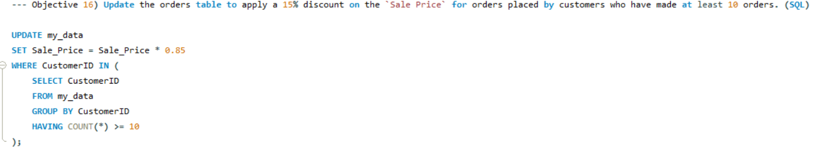

- Calculate the average number of days between consecutive orders for customers who have placed at least five orders. (SQL)
Answer: Since there is no customers with at least five orders - the output is showing BLANK
Query:
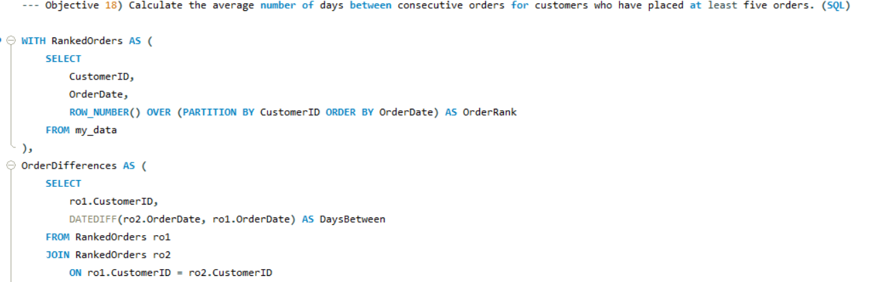
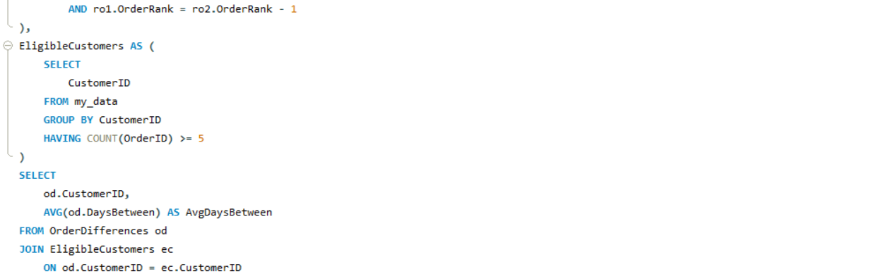
Output:
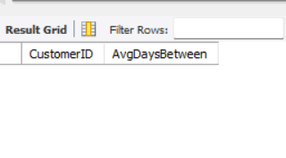

- Identify customers who have generated revenue that is more than 30% higher than the average revenue per customer. (SQL)
Answer: There are 1000 customers with more tha 30% higher than avg revenue per customer.
Query: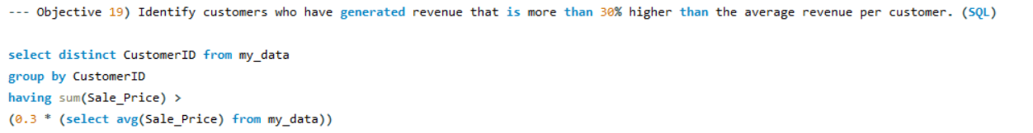
Output:
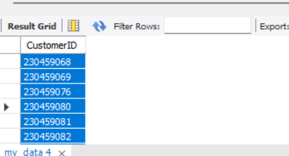

- Determine the top 3 product categories that have shown the highest increase in sales over the past year compared to the previous year. (SQL)
Answer: Phones and Tablet, Electronics & Fashion are the top 3 products.
Approach: Used 2 CTEs - one to create 2019_Revenue and 2nd to create 2020_Revenue and then found the difference and later used limit to find the top 3.

Query:
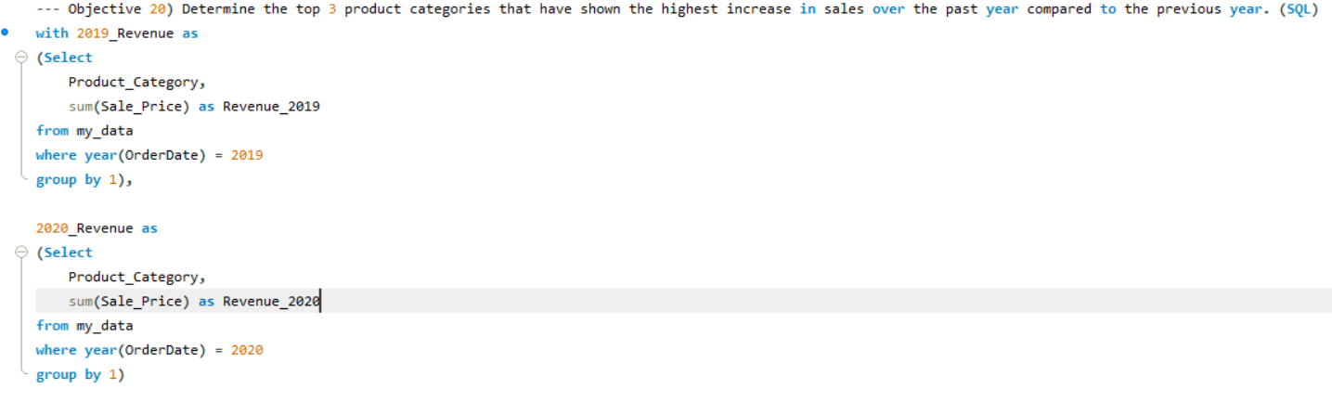
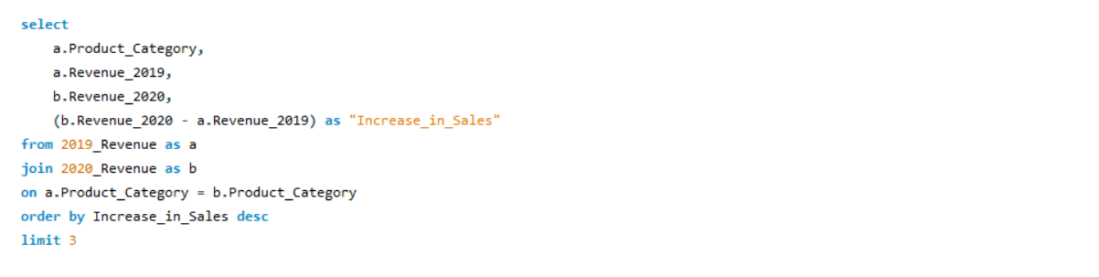

Output:
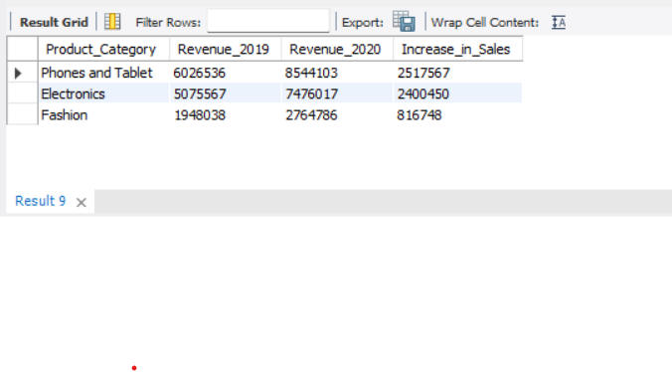

Subjective Question:

- Explain the revenue breakdown by year and by-product. Evaluate how different products contribute to annual revenue and come up with suggestions to increase the sales of the low-selling items.
Answer: Answer provided in PBI Report, Page Name - Subjective 1
Observation : Below are the products which are low selling - I have identified these products as they are the only products which do not contribute 1L yearly revenue, and to increase their revenue we will have to increase their Unit Price.
- M4 Smart Bracelet Sports Pedometer Watch
- Short Sleeve Polo Shirt - Royal Blue
- Cq Amaigrissant Slimming Tea - 20 Tea Bags
- Leather Vintage Bracelet Watch - Black
- Yazole Analog Quartz Wrist Watch - Black
- Clere Radiance Oil Control Toner - 100ml
- Clere Avocado Milk Body Lotion With Vitamins E+A - 400ml
- Yazole Leather Wrist Watch - Black
- Hemani Ultra Slim Tea - 10 Bags
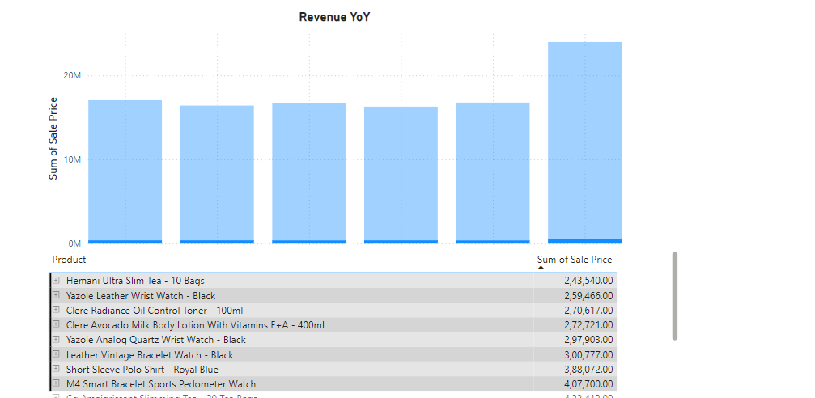

- How many products were returned? Use a DAX function to get this metric. Examine the possible reasons for returns and consider how this metric could indicate improvements in product descriptions or quality control.
Answer: 31K products were returned.
Approach: Used below DAX to calculate the count of returned products. “Returned_Count = COUNTROWS(FILTER(Orders,Orders[Status]="Returned"))”. Then the column chart to plot the reasons for returns.
Observation: Wrong, Missing & Defective Item contributes to 18K of returned products which means 58% of the total return%. By implementing more strict quality control during dispatch, we can greatly reduce this number. Whereas by specifying accurately about the product in the description we can reduce about 42% of the returns,

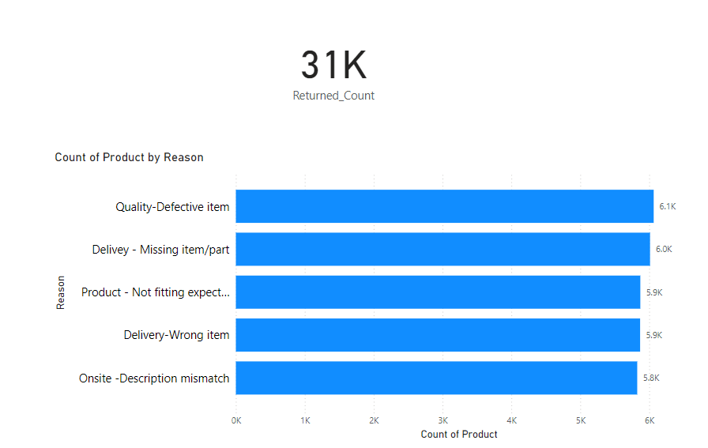

- Whenever a customer goes to Amazon, they’ll filter the most rated products to buy the better category. Can you verify this using any visualization or table that the ratings of products impact their sales value?
Answer: Ratings of the product is not impacting the sales value - in fact its the other way around
Approach: Used Clustered Bar chart to plot the Ratings on the X-axis and Sale Prices in the Y-axis and then brought the Product Category in Legends.
Observation: Ratings are not impacting the sales of the product instead less ratings are showing high sales value in below visualization.

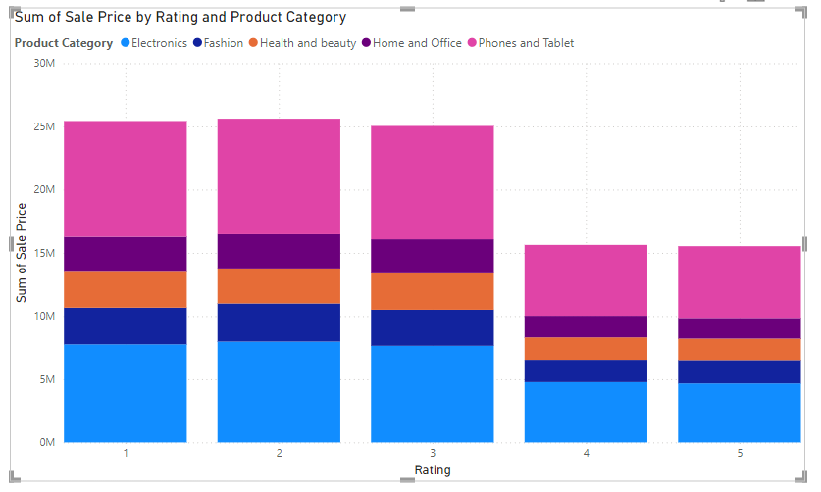

- Investigate how revenue distribution varies across different locations. Explore which geographical areas contribute most to sales and consider the strategic implications for regional marketing and distribution efforts. How might location-based trends inform the company's market segmentation and resource allocation approach?
Answer: East Africa & Center of North America are the regions with high revenues.
Approach: Used Map to fetch the location and used the Sale Price in Bubble field.
Observation:
1. Identifying High-Performing Location: Locations with consistently high revenue indicate strong market demand and customer engagement.
2. Recognizing Underperforming Locations: Locations with low or declining revenue may indicate untapped potential, competitive challenges, or lack of awareness.
3. Regional Preferences for Products/Services: Certain locations may favor specific product categories or services.
4. Seasonal Trends: Revenue spikes or drops may correlate with seasonal or cultural events in specific locations
5. Urban vs. Rural Distribution: Urban areas may generate more revenue, while rural areas may show slower growth.
6. Cost Efficiency in Operations: Revenue distribution can reveal locations where operational costs are disproportionate to the revenue generated.

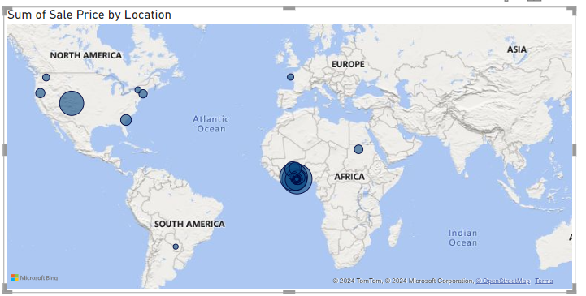

- Determine which month could benefit from enhanced promotional offers to boost sales. Can you suggest some targeted marketing strategies here?
Answer: June, September and November are the months with less revenue so we should plan promotional offers in this period.
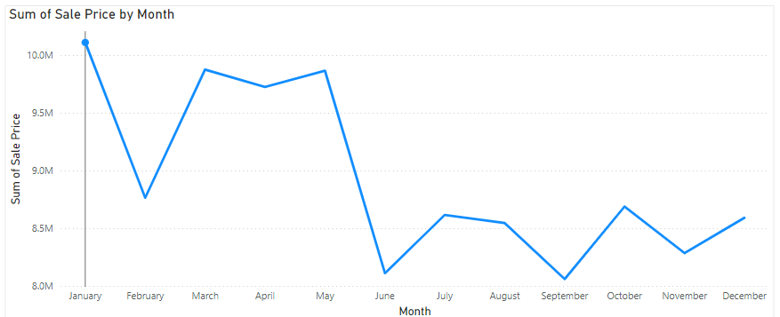

Approach: Used Line Chart to plot Months in X-Axis and Sales in Values.
Observation:
1. June (Mid-Year Slowdown)
Target Audience: Customers preparing for summer or mid-year activities.
Strategies:
- Summer Sales Event: Promote seasonal items with discounts (e.g., summer clothing, outdoor gear).
- Pre-Vacation Bundles: Offer travel or holiday packages for vacation-goers.
- Engage with Influencers: Partner with influencers to promote summer products on social media.
- Loyalty Rewards: Double loyalty points for purchases made in June to incentivize spending.
2. September (Back-to-School/Pre-Holiday Dip)
Target Audience: Students, parents, and professionals adjusting to post-summer routines.
Strategies:
- Back-to-School Promotions: Discounts on school supplies, electronics, or educational tools.
- Pre-Holiday Sneak Peek: Launch early bird offers for upcoming holiday sales (e.g., discounts for early shoppers).

3. November (Pre-Holiday Lull)
Target Audience: Shoppers preparing for year-end festivities but hesitant to spend before Black Friday or holiday sales.
Strategies:
- Pre-Black Friday Teasers: Offer limited-time deals to build excitement for Black Friday.
- Gift Guide Campaigns: Create and share gift guides tailored to different demographics.
- Free Shipping Offers: Encourage purchases with "Free Shipping Week" promotions.

- Identify which products may require increased marketing efforts. Which items have high prices yet underperform in sales?
Answer: Below are the products which will require increased marketing efforts
- Samsung Galaxy A02 - 64GB HDD - 3GB RAM Smartphone - Black
- Infinix Smart HD X612 (2021) - 32GB HDD - 2GB RAM - Black
- Samsung A3 Core Dual SIM - 16GB HDD - 1GB RAM - Blue
- 6030 3.1 Bluetooth Home Theatre With Remote Control - Black + Free Smartwatch
- 10.1'' Business Tablet with MT6582 Quad-Core Processor
Approach: Items with Unit Price above 300 were filtered and then Sales Price was plotted in Visualization - above mentioned products are having high unit prices but sales price below 10M

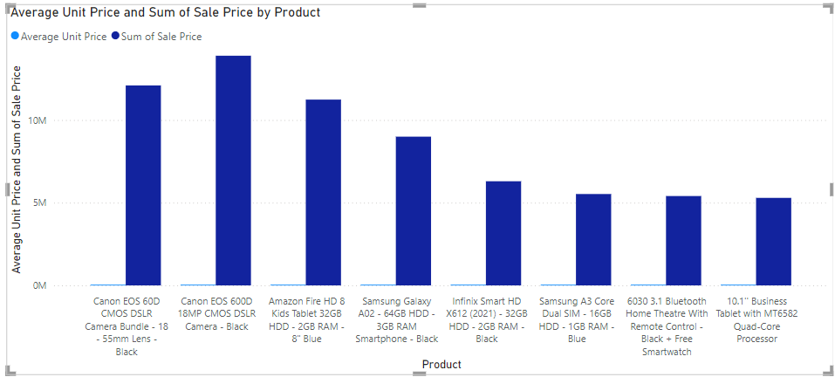

- Assess which products should have discounts. How can targeted incentives drive sales and customer loyalty for specific products?
Answer: Below products should have discounts
- Samsung Galaxy A02 - 64GB HDD - 3GB RAM Smartphone - Black
- Infinix Smart HD X612 (2021) - 32GB HDD - 2GB RAM - Black
- Samsung A3 Core Dual SIM - 16GB HDD - 1GB RAM - Blue
- 6030 3.1 Bluetooth Home Theatre With Remote Control - Black + Free Smartwatch
- 10.1'' Business Tablet with MT6582 Quad-Core Processor
Approach: Below items in visualization have high unit price but above mentioned products have not crossed 10M sales - hence we can create discounts for these products.

Observation:
1. Samsung Galaxy A02 - 64GB HDD - 3GB RAM Smartphone - Black
- Trade-In Discounts: Offer discounts for customers trading in older phones.
- Bundled Accessories: Include a free phone case or screen protector.
- EMI Offers: Provide zero-interest financing for affordability.

2. Infinix Smart HD X612 (2021) - 32GB HDD - 2GB RAM - Black
- Loyalty Points: Double loyalty points on this product to encourage purchase.
- Seasonal Discounts: Offer a "Back to School" discount targeting students.
3. Samsung A3 Core Dual SIM - 16GB HDD - 1GB RAM - Blue
- Localized Promotions: Discounts in regions where dual-SIM functionality is a priority.
- Extended Warranty: Offer free extended warranties to build trust.
- Buy-One-Get-One Offer: Provide a discount on the second unit for family purchases.
4. 6030 3.1 Bluetooth Home Theatre With Remote Control - Black + Free Smartwatch
- Bundle Discounts: Offer discounts when paired with TVs or gaming consoles.
- Limited-Time Flash Sales: Create urgency with short-term promotions.
5. 10.1'' Business Tablet with MT6582 Quad-Core Processor
- Corporate Discounts: Offer bulk discounts for companies or educational institutions.
- App Trials: Include free trials for productivity apps or cloud storage.

- Come up with a loyalty program to benefit the company’s customers. From the available lot of customers come up with strategies to bucket them and provide benefits under different loyalty programs.
Answer: I have created a new column “Customer Tier” which categorizes customers on the amount of the sales they create.
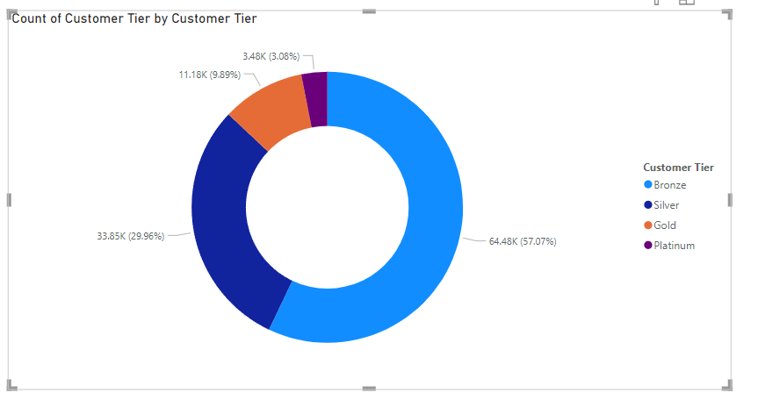
Approach: Created a Donut chart for visualization.
Observation:
Platinum Tier: Sales over 5K
Benefit: Highest discounts, birthday offers, exclusive invites to product launches, free gifts.
Gold Tier: Sales over 2K
Benefits: Higher discounts, personalized offers, free shipping, or VIP customer service.
Silver Tier: Sales over 500
Benefits: Discounts on certain products, exclusive offers, early access to sales.
Bronze: Sales under 500
Benefits: First-time purchase discount, loyalty points on the next purchase.

- Using the DAX functions Calculate and a row iteration DAX function calculate the total sales for the Product Category “Fashion” and delivery type “Shipped from Abroad”. What are the other types of DAX functions you have used in the project?
Answer: 4.14M is the revenue under this filter.
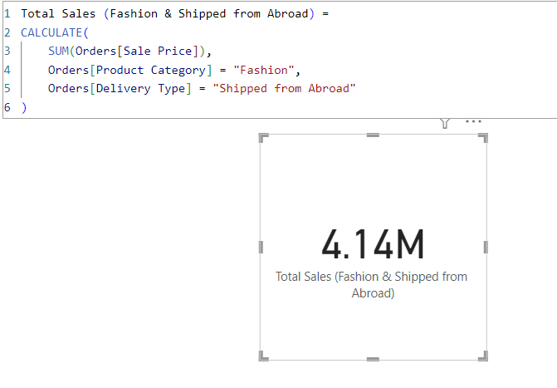

- Wait Times Correlated with Demographics and Care: Explore how average wait times vary across different product categories to optimize scheduling and staffing.
Answer: Average Delivery Days is same across all Product Category i.e 10 days.
Approach: First calculated the wait time by creating a new column : Delivery Days with datediff function. And then used Column Chart to plot the Category wise Average Delivery Days.
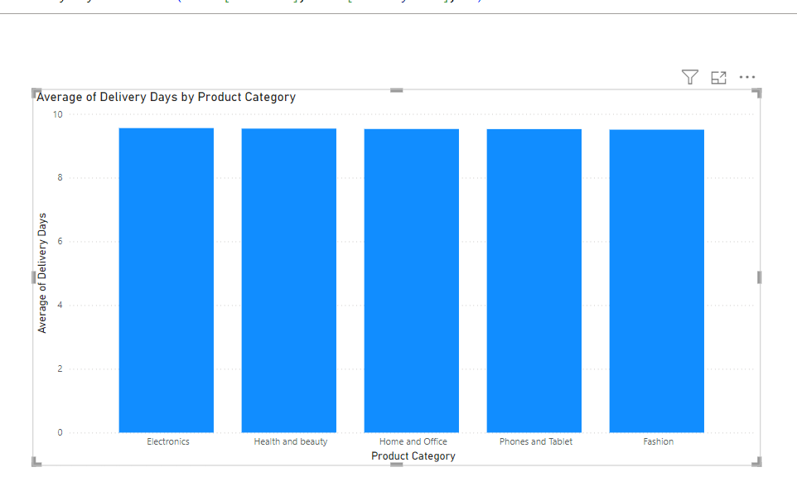

- Explore if there is any relationship between the Delivery type and waiting time between ordering and receiving an item.
Answer: Yes, Express Delivery Type’s wait time is very less as compared to the remaining types.
Approach: Used Column Chart to plot the Avg Delivery Days and Delivery Type view.
Observation: Express delivers the products within 4 days - and the most wait time is taken by Shipped from Abroad Type ~15 days

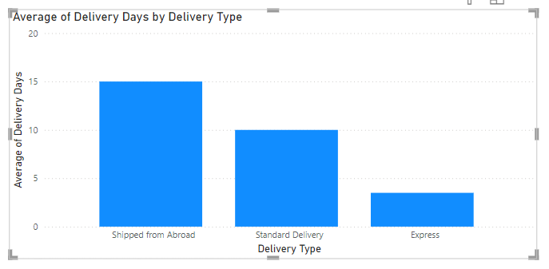

- Is there any relationship between shipping charges and product type?
Answer: Shipping Charge is the same across all Product Type, no change is seen
Approach: Used Column Chart to plot the Shipping Fee and Product Category in Column Chart.

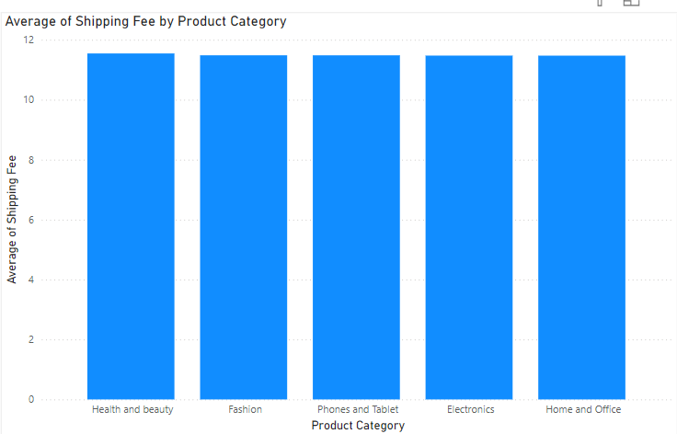
- Come up with strategies to decrease the low rating orders after analyzing different factors like waiting time, shipping type, unit price, etc.
Answer: Below visualization shows the difference between each of the metrics for lower ratings (<3 ratings) and high rated orders (4&5 ratings).
Observation:
Waiting Time is same across the ratings - which means wait time is not impacting the ratings of the products.
In Shipping Type - Standard Delivery and Express is mostly being used - which means for increasing the rate instead of Shipped from Abroad, products should be mostly in Express type.
Average Unit Price should also be reduced - as this can also help in increasing the ratings.
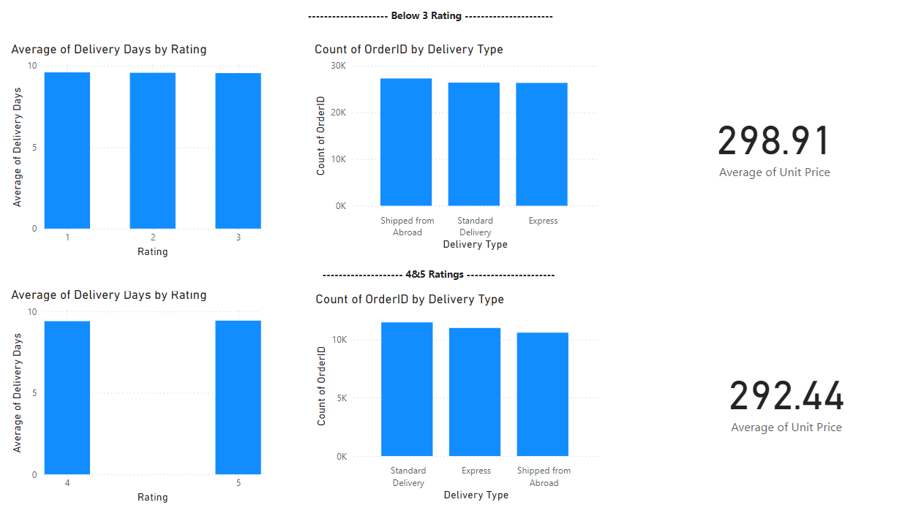
- Using the time intelligence DAX function, create a table to compare each month’s sales with the previous year’s same month’s total sales. So there will be four columns in the output year, month, total sales, previous_years_sales.
Answer: Created DAX “Previous_Year_Sale” with below formula.

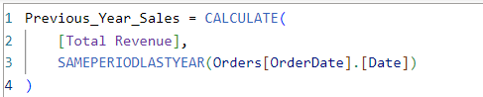
Approach: Created Table where Month-wise previous year's same period sale is plotted in the table.
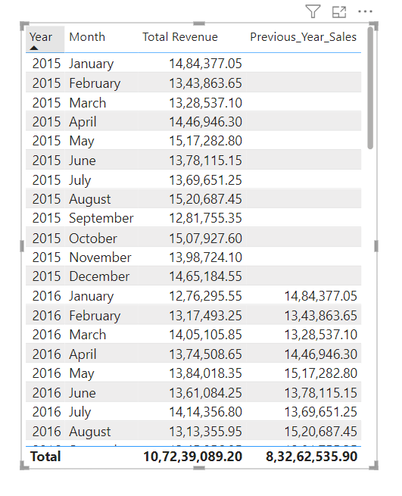

- What do you understand by PowerBI gateway? What are its use cases?
Answer: A Power BI Gateway is a bridge that connects on-premises data sources (like SQL Server, Excel, etc.) to the Power BI service in the cloud, enabling secure data transfer for reports and dashboards
Key Use Cases:
- Scheduled Data Refresh: Automates refreshing Power BI reports with updated on-premises data.
- Live Data Access: Enables real-time interaction with on-premises datasets.
- Hybrid Data Models: Combines on-premises and cloud data for unified analysis.
- Secure Data Transfer: Ensures encrypted communication between local sources and the cloud.
- Collaboration: Allows teams to share and access up-to-date reports.
- File Access: Connects local files (Excel, CSV, etc.) to Power BI reports.
Benefits:
- Automation: Keeps reports updated.
- Security: Transfers data safely without leaving your network.
- Versatility: Supports diverse data sources.

- How would you approach this problem, if the objective and subjective questions weren't given?
Answer: I would have used below approach:
Sales Performance:
- Total sales by year, zone, product category, and subcategory.
- Identify top-selling products and underperforming ones.
Customer Behavior:
- Analyze order frequency, average order value, and most preferred product categories/subcategories.
- Segment customers by location, order quantity, and ratings.
Delivery Efficiency:
- Calculate average delivery days across zones and delivery types.
- Identify trends in late deliveries by analyzing "Delivery Days" vs. "Status."
- Study the correlation between delivery delays and customer ratings.
Revenue Analysis:
- Break down revenue by unit price, shipping fee, and sales price.
- Investigate the profitability of different product categories by analyzing the difference between sales price and unit price.
Order Status and Cancellations:
- Track the proportion of completed, canceled, and returned orders.
- Analyze reasons for cancellations or returns by product category and subcategory.
Seasonality and Trends:
- Examine how sales, ratings, and delivery times vary across months or years.
- Identify peak order periods and their impact on delivery efficiency and customer satisfaction.

Report:
The stakeholders have asked for three tabs in the Reporting:
- Main Tab
- Product Tab
- Individual product Tab

- Using the Main tab in the Report, Stakeholders should be able to look at the total sales, revenue produced till now, and customer satisfaction for all product categories. This tab should have a slicer of product category and date.
- Using the product Tab, the management at the company should be able to look at the individual product category-wise performance like customer satisfaction, the number of customers purchasing that product, and which product requires improvement. This tab should have a slicer of gender, delivery type, product category, and age group
- Using the Individual product Tab, the Management and Stakeholder in the company want to look at the best product profile which would involve their total purchase, ID of that product, category/subcategory of that product, average rating, and how much revenue was generated by this product. All the metrics using which they can address the product very carefully in their orders.

Make sure that all the visualizations look decent and are placed in a proper order. Each tab has different POCs (Point Of Contact), so make sure you involve all the metrics that POC may look at in that tab along with those mentioned in the tab description.

